**WHAT IS QR CODE:**

[A QR (Quick Response)](https://en.wikipedia.org/wiki/QR_code) code is a much more advanced version of a barcode that we usually see attach to customers’ goods when we go to grocery stores or supermarkets.

A QR Code can be generated using a QR code generator online and can be scanned in both vertical and horizontal dimensions.

It can store so much more information that comes in various forms, unlike barcodes, that only provides the numeric value of a product.

Barcodes functions in horizontal dimension only and requires a specific machine to be read, QR codes are accessible to smartphones using only its camera feature or QR Reader Apps just by scanning it, which makes it convenient for everyone. 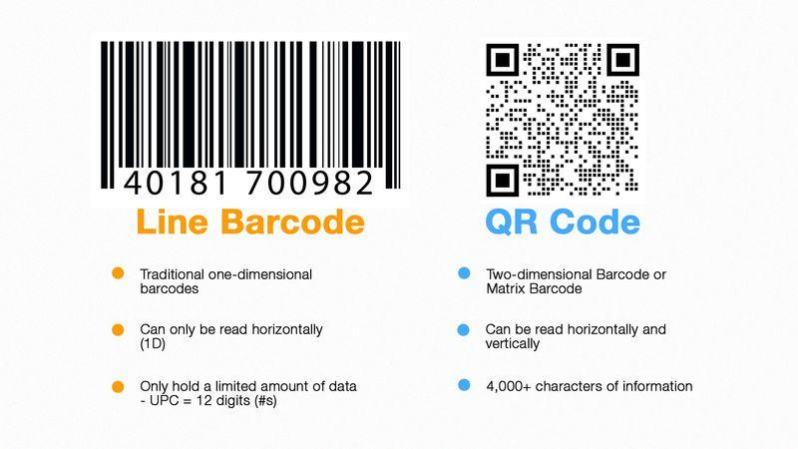

### **TYPES OF QR CODE**

### **Static QR Code**

The difference between static and dynamic QR code is that static QR codes have a very dense pattern and less scannable. The information stored in this type of code is fixed, and it does not allow changing of the destination address of the data or URL once generated.

Furthermore, it does not allow you to track the data of the scans and only leads you to one URL. The code that is being embedded is hard-coded and cannot be altered

### **Dynamic QR code**

Dynamic QR codes use short URLs and works better to scan as the pattern is less dense.

Dynamic QR code allows you to track data and you can [edit your URL or content](https://www.qrcode-tiger.com/edit-a-qr-code) at any time to any other URL, this saves you time and money on printing.

With a static QR, the user will go directly to your URL, however, data cannot be tracked and you are unable to edit your URL.

For marketing, Dynamic QR codes are more useful as you can set-up your[QR code tracking system](https://www.qrcode-tiger.com/qr-code-tracking)and track the number of scans, the time when the user scanned, the location of the scan (city/country), and the device type of the user (iPhone/Android).

It is important to remember that Static QR Codes are only good for personal use, one-time use is not ideal for business, and has a limitation to the content of the QR Codes

**USE OF DYNAMIC QR:**

For business and marketing:

Dynamic QR codes are more useful as we can have access and track the number of scans, the time when the user scanned, the location of the city or country, and the device type of the user.

We can track the data of your customers, the prospective consumers, and what particular location you sell the most.

If we are into the business sector and we have not used the QR Code, then we already lose half of our customers in the market.

The relevance of QR Codes in our business dealings and day to day transactions can help us heighten and escalate the demands of the product we offered, goods, or services and even accumulate new customers.

Dynamic QR codes are great to update all our QR codes at once. For example, We can redirect our QR code to one web page, and whenever we want, we can update all our QR codes in the back office to any new web page.

This way, it saves our time and money as we never need to reprint flyers or update any consumer product out there. Dynamic QR codes are relevant for any business.

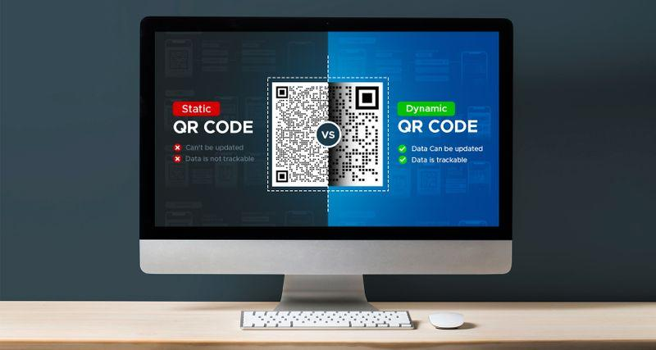[**SOURCE**](https://www.qrcode-tiger.com/what-is-the-difference-between-static-and-dynamic-qr-code)